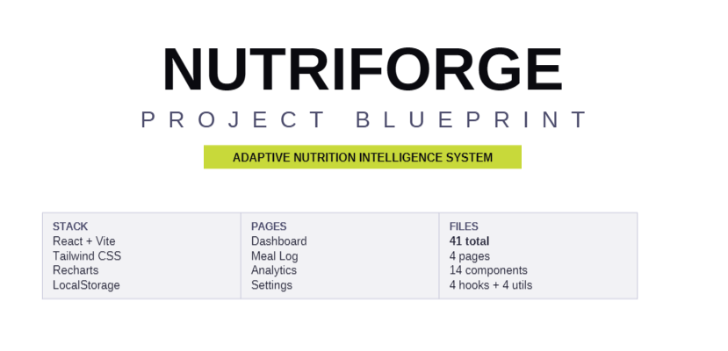


Project Overview
NutriForge is a personal, fitness-focused nutrition tracking web application designed to help users achieve body transformation goals through structured calorie and macronutrient management. The system allows users to track daily nutrition intake, monitor body progress, and maintain long-term consistency while pursuing cutting, bulking, or maintenance goals. Rather than functioning as a simple calorie logger, the application focuses on goal-based nutrition planning, progress analytics, and behavioral discipline tracking.
Project Goal
The primary goal of NutriForge is to provide a structured nutrition management tool that helps users make data-driven decisions about their diet and fitness progress. The application calculates personalized calorie and macronutrient targets, tracks daily food intake, monitors body weight trends, and evaluates adherence to nutrition goals. By combining automated calculations with progress visualization and consistency tracking, the platform aims to support sustainable and measurable body transformation.
Technology Stack
The application is built using React with a Vite development environment to create a component-based frontend architecture. Tailwind CSS is used for styling and layout design, enabling a modern and responsive user interface. Data visualization is implemented using Recharts to display nutrition and progress trends. Application state is managed using the React Context API and custom hooks, allowing shared access to nutrition data and calculation logic. User data such as nutrition logs and progress metrics are stored locally using browser LocalStorage for persistence.
Core Features
The system begins with an onboarding setup where users enter basic information including weight, height, age, gender, activity level, and fitness goal. Calorie targets are adjusted according to the selected goal: a deficit for fat loss, maintenance for weight stability, or a surplus for muscle gain. Macronutrient targets are derived from the calorie target, with protein based on body weight, fats representing a portion of total calories, and carbohydrates filling the remaining energy requirements.
The main dashboard provides a daily overview of calorie intake and macronutrient distribution, allowing users to compare their consumption against their targets. A meal logging system enables users to add foods and automatically track calories, protein, carbohydrates, and fats. In the initial version, the application uses a static food database, with the potential for API-based food lookups in future updates.
The platform also includes a discipline scoring system that evaluates how closely a user’s daily nutrition aligns with their targets. The score considers calorie accuracy, protein intake, fat balance, and meal logging consistency, producing a numerical measure of adherence to the nutrition plan. A consistency calendar visualizes long-term adherence patterns using a grid similar to contribution graphs.
Body progress tracking allows users to log weight and other optional measurements such as body fat percentage or waist circumference. These values are visualized using charts to display trends and rates of change over time. The system also generates periodic summaries that analyze average calorie intake, protein consumption, weight change, and overall consistency. Based on these trends, the application can suggest adjustments to calorie targets if the user’s progress deviates from the intended goal.
Unique Value Proposition
The distinguishing aspect of NutriForge is its emphasis on discipline and progress rather than simple calorie tracking. Most nutrition tracking applications function primarily as logging tools, while NutriForge integrates goal-based macro planning, adherence scoring, and progress analytics to create a structured transformation system. By linking nutrition behavior with measurable outcomes and providing adaptive feedback, the application functions more like a digital nutrition coach than a basic tracker.

